Hardy-Weinberg Principle and Equations

The Hardy-Weinberg Principle states that the amount of genetic variation in a population (allele and genotype frequencies) will remain constant from one generation to the next in the absence of evolutionary forces. Of course this doesn’t really happen but allows a comparison of frequencies between expected (ideal conditions) and observed (with evolutionary forces) in a population.

For more information see https://www.youtube.com/watch?v=oG7ob-MtO8c

By knowing the number of non-tasters (the recessive trait) we can calculate the expected number of homozygous and heterozygous tasters using the Hardy-Weinberg equations.

p = dominant allele frequency
q = recessive allele frequency

genotype frequency = # of individuals of a given genotype in the population
_______________________________________________________________________________________________________________________________
total # of individuals in the population

Allelic frequency = # of copies of an allele in a population
____________________________________________________________________________________________
Total # of alleles in a population

p + q = 1

p² + 2pq + q² = 1

p² = frequency of homozygous dominant genotype (TT)

2pq = frequency of heterozygous genotype (Tt)

q² = frequency of homozygous recessive genotype (tt) -Can be counted in a population based on phenotype.

Note: the frequency of heterozygotes is 2pq because there are two different ways to make that genotype. (Tt and tT)

We can consider the allele and genotype frequencies of a population to be in Hardy-Weinberg equilibrium if they are not changing over many generations. But Hardy-Weinberg equilibrium comes with some assumptions:
1. No selection, migration or mutation
2. Allele frequencies are equal in both sexes
3. Generations are non-overlapping
4. Large population size (reduces chance events)
5. Random mating

Alleles | Allele Frequency
T
t

Phenotype | Genotype | Genotype Frequency
Taster | TT
Taster | Tt
Non-taster | tt

P = frequency of T
q= frequency of t

Number of people in the class who are tasters ___________

Number of people in the class who are non-tasters ___________

Total number of individuals in the class population ___________

Use the Hardy-Weinberg equation to calculate the following:

What is the frequency of the non-taster genotype? ___________ (q²)

What is the frequency of the non-taster allele? ___________(q)

What is the frequency of the taster allele? ___________(P) = (1-q)

Given the frequency of non-tasters in the class, what would you expect the frequency of heterozygous tasters to be? (using Hardy-Weinberg)
_______________(2(P)(q)

Expected frequency of homozygous tasters? (using Hardy-Weinberg) _______________(P²)

How do the allelic and genotypic frequencies of the class compare to what you predicted using the Hardy-Weinberg equation?

What might cause differences between the predicted and calculated frequencies?

More Hardy-Weinberg

Between Ithaca and Geneva, NY at the old Seneca Army Depot is a herd of white tailed deer. There are 800 individuals in the population, 200 of which are white (yy). Typically expression of this recessive allele makes the individuals more susceptible to predation. But the old army base is fenced off, providing protection from most predators. These deer are not albinos, but rather leucistic (lacking pigmentation in their hair only).

Alleles | Allele Frequency
Y
y

Phenotype | Genotype | Genotype Frequency
Brown | YY
Brown | Yy
White | yy

What is the frequency of the recessive (white) genotype?

What is the frequency of the recessive allele?

What is the frequency of the dominant (brown) allele?

What is the predicted frequency of heterozygotes in the population?

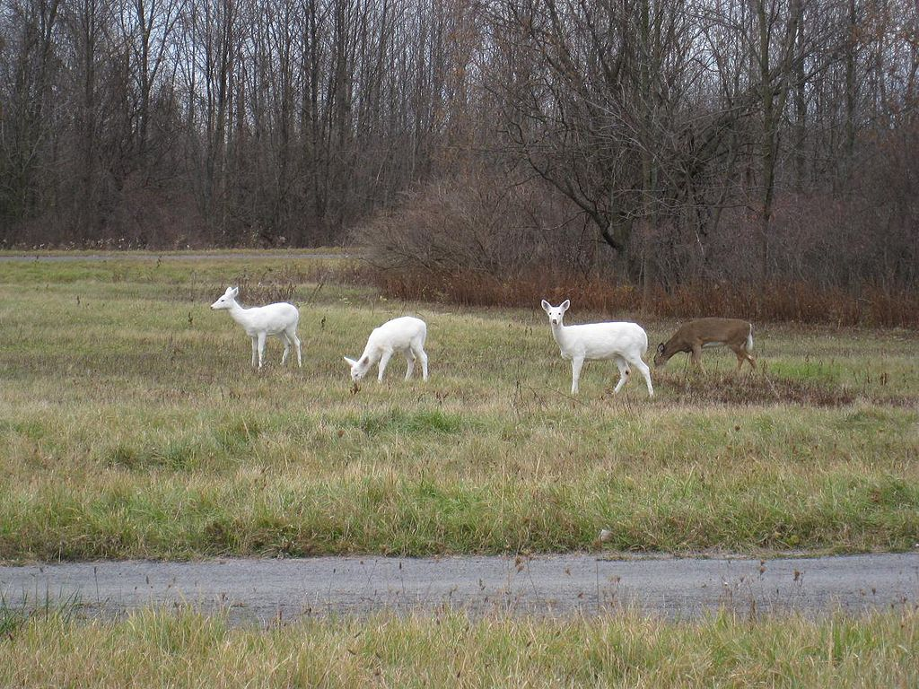
https://commons.wikimedia.org/wiki/File:Seneca_White_Deer_On_Army_Depot_Grounds_1.JPG

